**A reverse causal analysis of Austrian Climate Policy**

***How much of the reduction in Austria’s emissions is really due to good policies? A new report suggests it might be less than you think.***

Austria’s emissions grew steadily from 1990 to 2005 and have dropped by about 21 million tonnes (or 25%) since then. Was this drop due to good policies or would this have happened anyway?

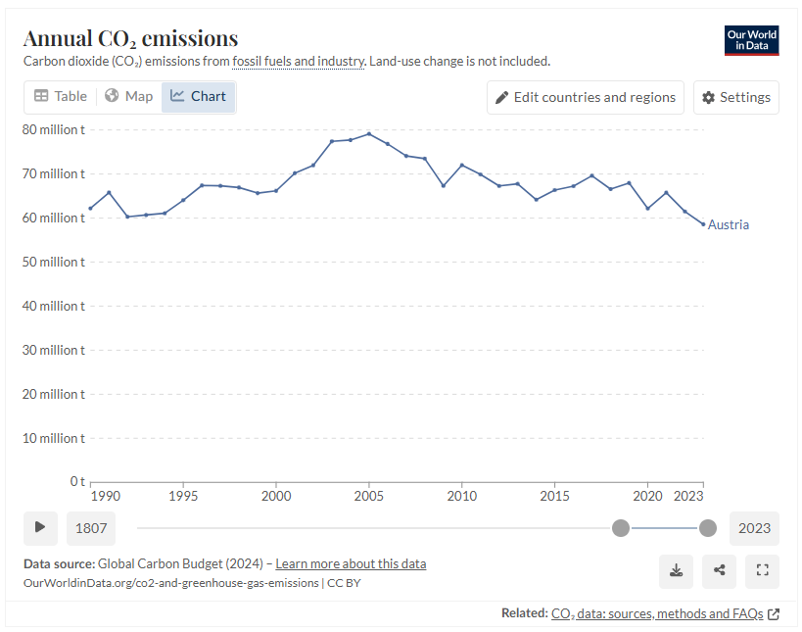

A [new report](https://doi.org/10.1038/s41597-024-04321-w) from the WU Department of Economics suggests that about 6.1 million tonnes of the reduction were caused by good policies.

This suggests that the majority of the reduction in emissions has been due to changes in socioeconomic determinants, and not necessarily national policies. This could include the impact of COVID19 lockdowns, general improvement in the efficiency of technology across all countries, or shifts in population dynamics.

Authors Talis Tebecis and Jesus Crespo Cuaresma published the report in Nature’s *Scientific Data* journal this week, along with a [new dataset](https://doi.org/10.5281/zenodo.13325884).

The dataset includes 7,500 “structural breaks” in emissions, or shocks in emissions that can’t be accounted for by economic, social and technological factors.

“*By controlling for these main determinants of emissions, you’re left with fluctuations that are most likely due to policies*,” says Tebecis.

“*Linking these breaks to specific policies gives you a list of the most effective policies in a country. The new dataset provides the basis for this type of analysis*.”

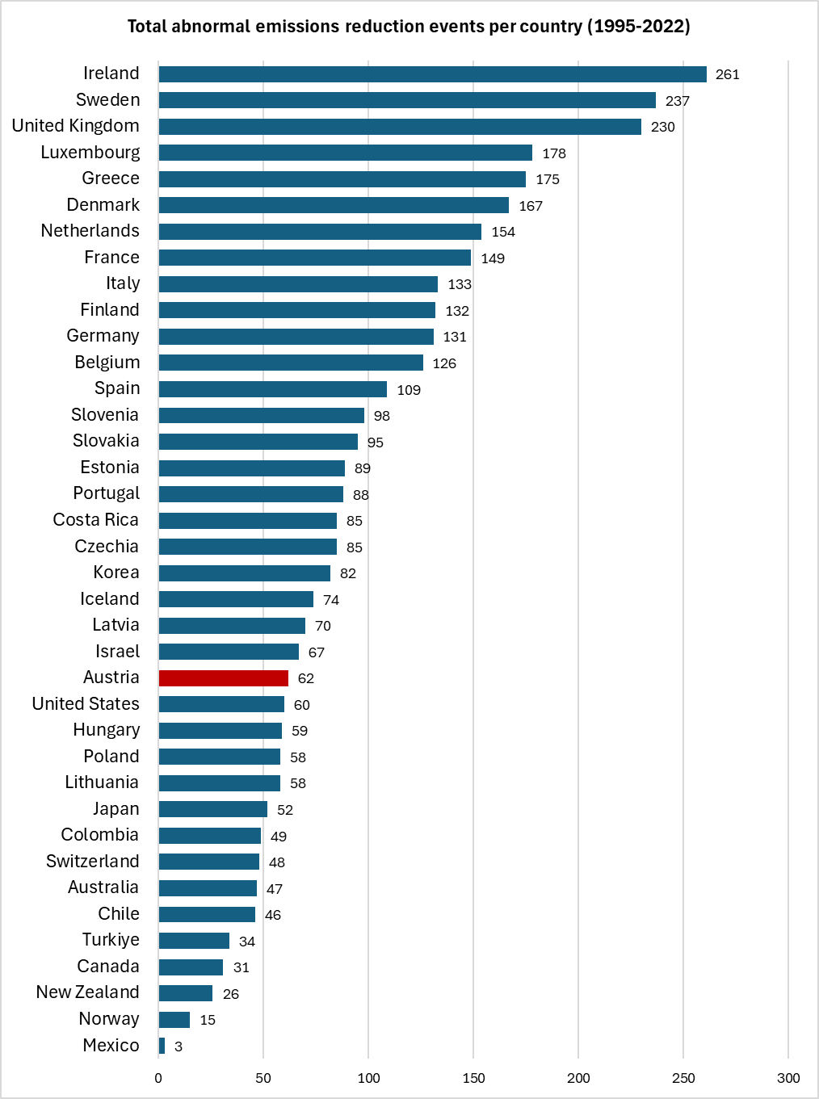Only 62 reductions in emissions (negative structural breaks) were found for Austria, compared to 261 for Ireland and 131 for Germany. In fact, Austria scored below most EU countries in this list, with only three other member states showing fewer breaks. Austria did, however, appear higher in the list than the United States and neighbouring Switzerland.

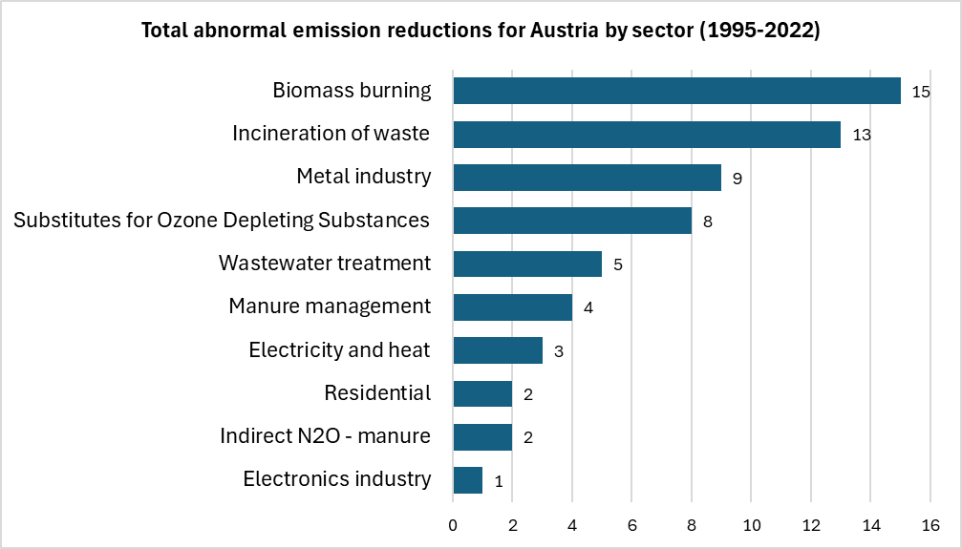A breakdown of emission reductions for Austria reveals the sectors where policies appear to have caused the biggest reductions in a given sector. “Biomass burning” and the “incineration of waste” are the sectors which showed the most reduction events, perhaps a testament to Austria’s regulatory support for sustainable biomass production and strict efficiency standards in the sector.

Three negative breaks were picked up in the “electricity and heat” sector, the second largest source of emissions for the country overall, making up one quarter of all emissions.

The data also show how big these reductions in emissions are for a given sector, with the largest average emissions reductions in the “metal industry,” “biomass burning” and the “incineration of waste.” While these sectors showed relatively big reductions in the given sector, the sectors themselves represent a relatively small proportion of Austria’s overall emissions.

Emissions from agricultural activities, such as “manure management,” appeared to result in relatively small reductions.

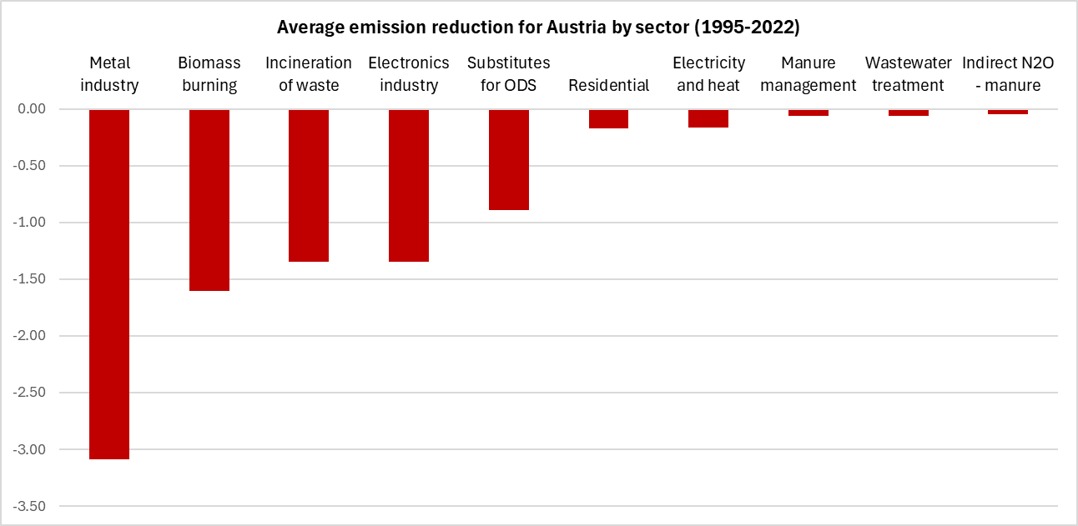

Prof. Crespo Cuaresma, head of the WU Department of Economics, commented on what this data could do for climate policy research going forwards.

“*When it comes to identifying the best policies, the devil is often in the detail. That’s why we go down to such a detailed level of analysis and look at 37 different sectors and all major greenhouse gases, not just CO2*.”

Tebecis and Crespo Cuaresma say that there are many more opportunities to benefit from research and make smarter climate policy decisions, and they say that this paper lays the foundation for more research to come.